The EasyMag definition was like this (only 1 definition with labels 1-8, 9-16) where 9-16 were in reverse order than expected:
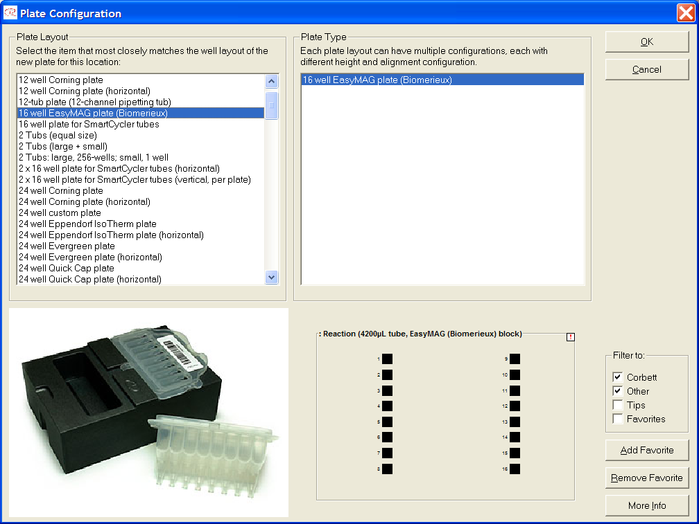

Now there are 2 EasyMag options:

1. Same pipetting sequence as before, top down in both columns, but with labels corrected as 1-8, 16-9.
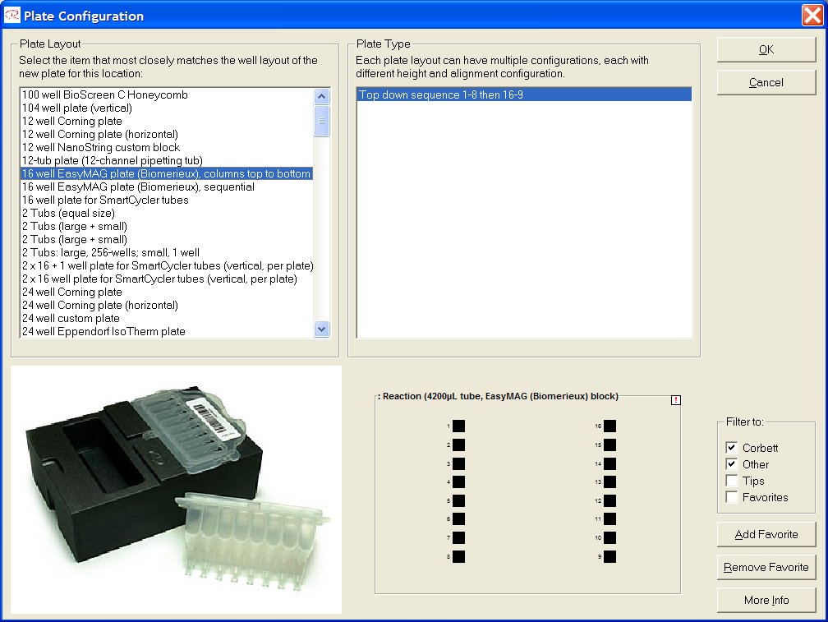

2. Sequential pipetting order 1 to 16 consistent with the labels.
