National Instruments PCI-GPIB Driver Installation Guide for Windows NT 4.0 and Windows 2000

- Exit all running programs (except Explorer) before start the installation.
- Make sure you have installed a National Instruments’ PCI-GPIB board in your system and connected to a CEQ (instrument or simulator).
- If you already have CEQ 2000 installed in your system (WinNT), remove the CEQPCINT driver from the Device Manager (contact Eric Chiang (x8658) for the detail).
- Run ni488216.exe.
- Press Setup to extract the installation files.

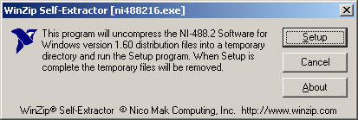

- Press Yes to accept the license.

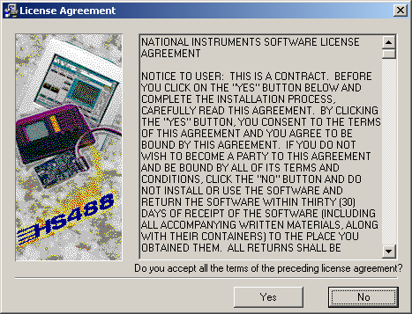

- Do not register. Press Next to continue.

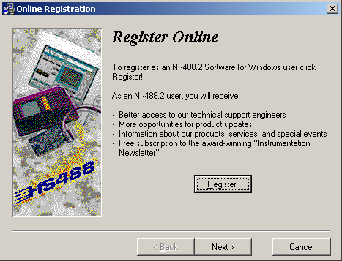

- Select the install directory. The default is C:\Program Files\National Instruments\NI-488.2. Press Next to continue.

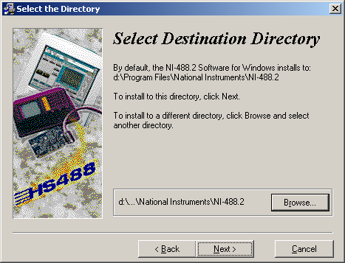

- Select the install components. We recommend Driver and Applications only.

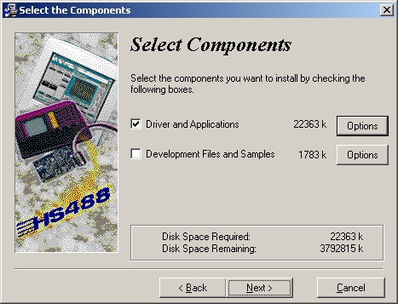

- Press Next to start installation.

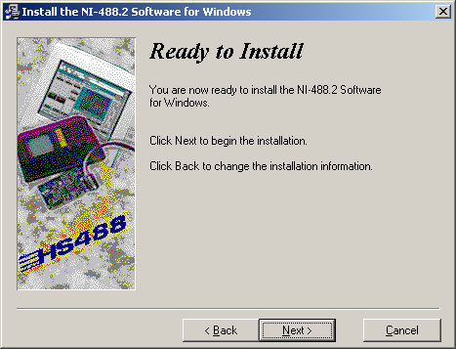

- After finish copying files, press Finish to complete the installation.

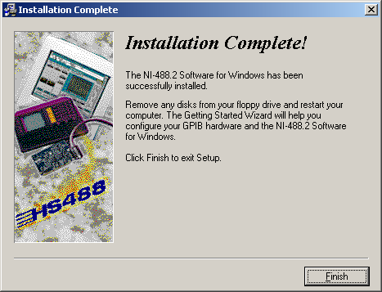

- Press OK to reboot the system (required).

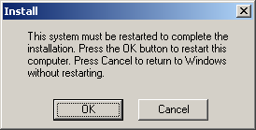

- After system starts up, the Wizard will guide you through the initialization. Click on “Verify your hardware and software installation”. You need to have a PCI-GPIB board installed and connected to a CEQ system.

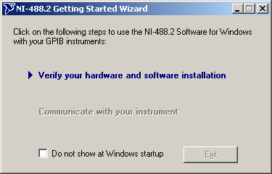

- After Wizard verified your interface, press Exit to continue.

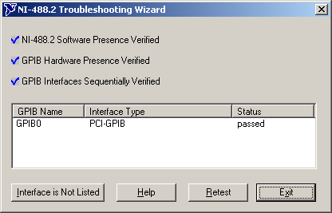

- Continue on to “Communicate with your instrument”.

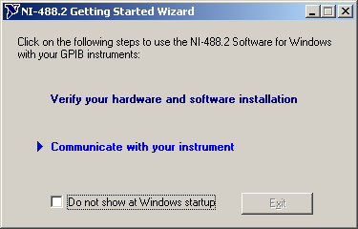

- Click on X to exit out this dialog. Do not click on Next.

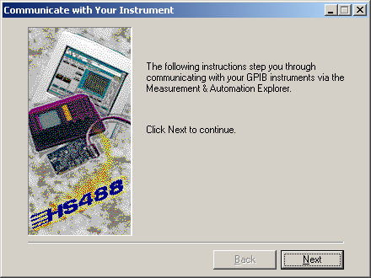

- Click on Exit to complete the Wizard verification procedure.

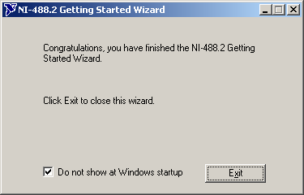

- Change the CEQ.INI for CEQ 2000 system to interface with the National driver.
[CEQRUN]
VXDNAME=CEQNIGPIB

